Configuring the cash drawer
Scenario: FC is emailing because they want to connect the cash drawer with the POS

- Log in to the AX5 point-of-sale system using your PIN.
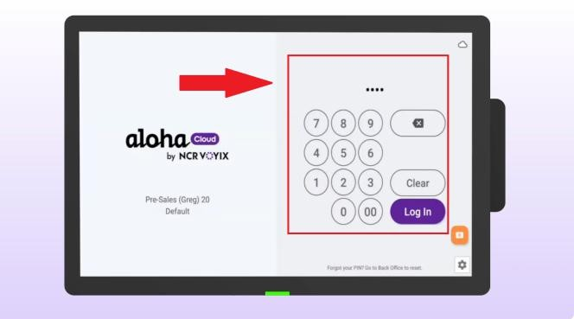
- Click on the menu in the top left corner.
- Select SETTINGS.
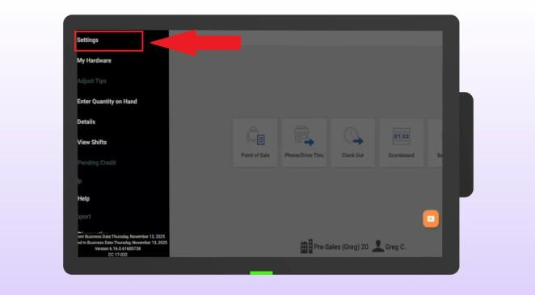
- Select CONFIGURE CASH DRAWER.
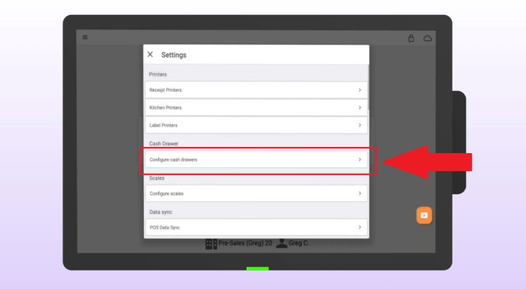

- Select POS CASH DRAWER PORT.
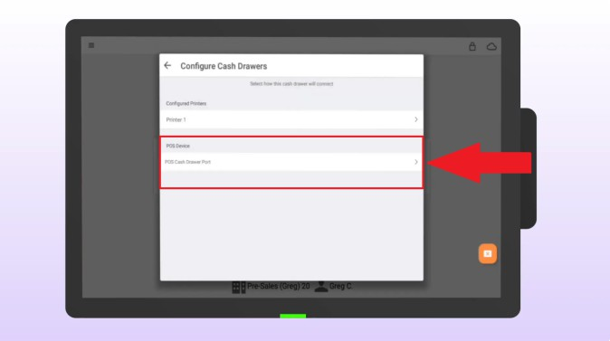
- Select CASH DRAWER ATTACHED
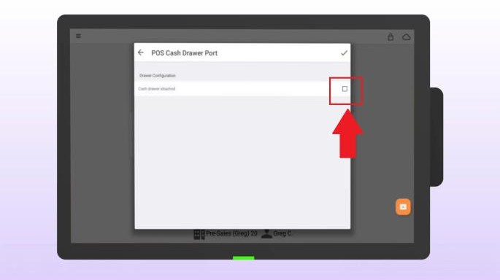
- Name your cash drawer.
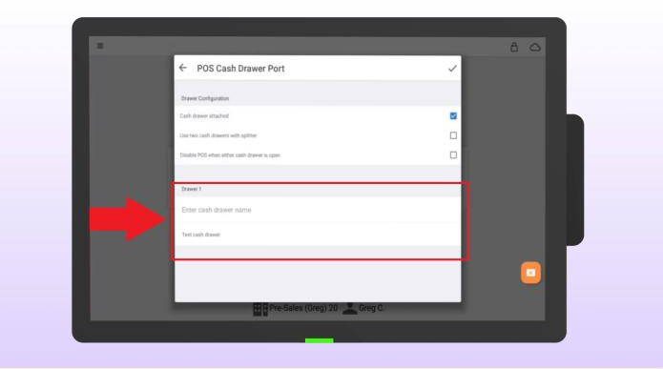
- Use a recognizable name. This name will appear at the end of financial reports at the end of the shift, e.g., "COUNTER-02."

- Tap TEST to make sure the drawer opens properly.
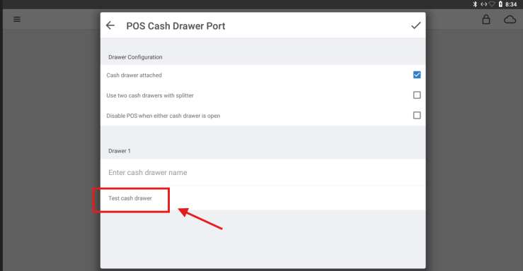
- When prompted, confirm that the cash drawer has opened by tapping YES.
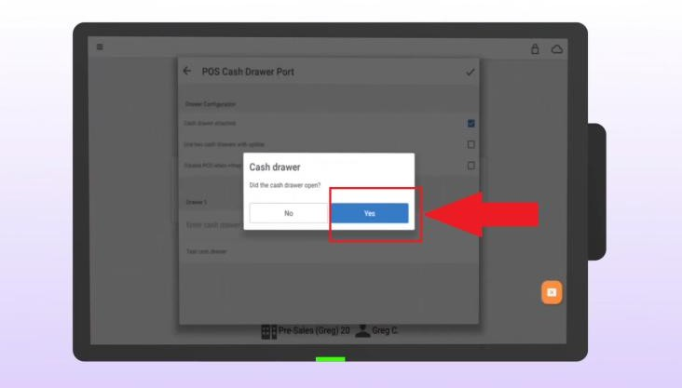

- Finally, tap the tick in the top right-hand corner.
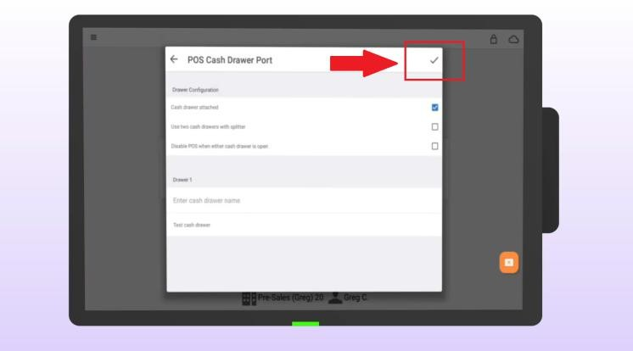
- Your cash drawer is now set up and ready to accept payment.

